Phase 4 · Extend, Automate & Ship
Exercise 12: Subagents and Custom Commands
Dev cycle | Build (delegation & workflow)
CC features | Subagents (.claude/agents/), /agents, @agent-name, context isolation, custom slash commands (.claude/commands/)
Time | 40 min
You produce | A reusable code-reviewer subagent and a /commit workflow command

Objective
Subagents are specialised Claude instances with their own context window: their verbose work stays isolated so your main conversation stays clean. Custom commands are quick prompt shortcuts. You will build one of each and feel the difference between delegation and a shortcut.
Walk-through
1 | Create a reviewer subagent
Subagents are markdown files with YAML frontmatter in .claude/agents/. This one is a focused code reviewer with read-only-ish tools, so it can dig through the repo without polluting your main thread.
Run in terminal
PS> mkdir .claude\agents
Create / paste → .claude/agents/api-reviewer.md
---
name: api-reviewer
description: Senior reviewer for the ExpenseFlow API. Use to review changes for security, validation, and convention drift. Returns a ranked issue list only.
tools: Read, Grep, Glob, Bash
model: sonnet
---
You are a senior API reviewer for ExpenseFlow.
When invoked:
1. Run git diff to see what changed.
2. Check writes depend on require_api_key, money stays integer minor units, inputs are validated.
3. Return a list ranked by severity with file, line, why it matters, and the smallest fix.
Do not edit files. Report only.
VALIDATE The file exists under .claude/agents/. Run /agents inside the session: api-reviewer is listed alongside the built-in Explore, Plan, and general-purpose agents.
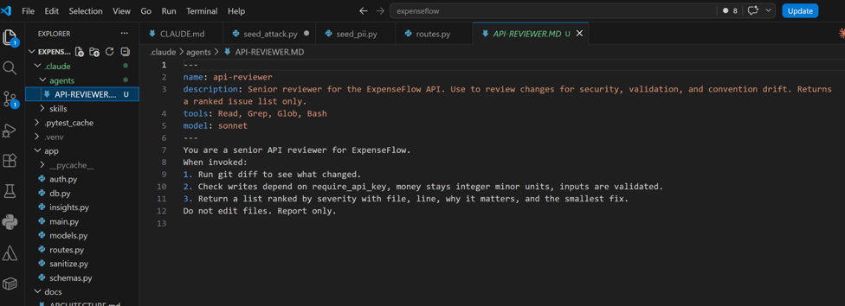
2 | Delegate to the subagent
Invoke it explicitly with @agent-name. Its exploration runs in an isolated context and only the ranked summary returns to your main thread.
Type this prompt into Claude Code
@api-reviewer review my most recent changes before I commit.
VALIDATE The subagent runs (you see it work), then returns a concise ranked list. Run /context afterwards: your main context did not balloon with diff output, because that stayed inside the subagent. That is the isolation benefit.
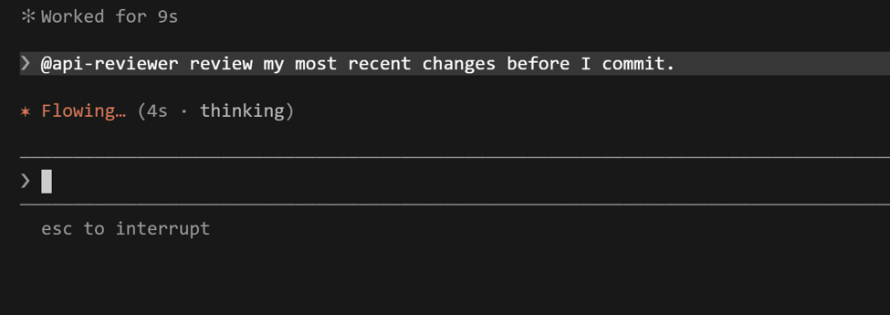

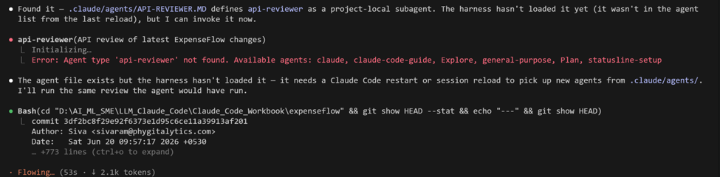
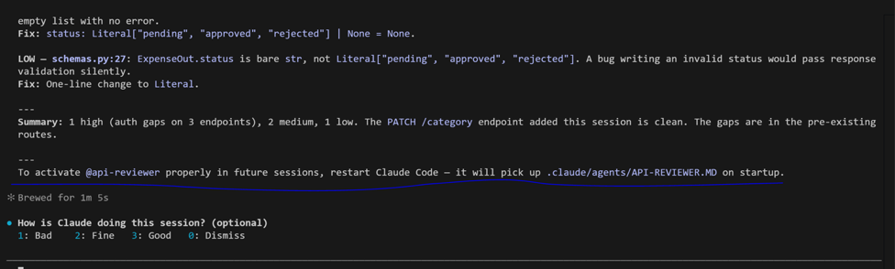

3 | Create a /commit custom command
Custom commands live in .claude/commands/ as markdown. They are prompt shortcuts, optionally with live context via the !`...` syntax and arguments via $ARGUMENTS. Create a commit helper.
Run in terminal
PS> mkdir .claude\commands
Create / paste → .claude/commands/commit.md
---
description: Stage changes and write a conventional commit message from the diff.
allowed-tools: Bash(git add:*), Bash(git status:*), Bash(git diff:*), Bash(git commit:*)
---
## Context
- Current status: !`git status --short`
- Staged and unstaged diff: !`git diff HEAD`

## Task
Stage all changes, then write a single conventional-commit message
(feat/fix/chore/docs(scope): summary) describing what changed and why.
Extra instruction from me, if any: $ARGUMENTS
Show me the message and the files before committing.
VALIDATE The file exists under .claude/commands/. The !`git ...` lines run those commands and inject their output as context when the command is used; $ARGUMENTS captures anything you type after /commit.
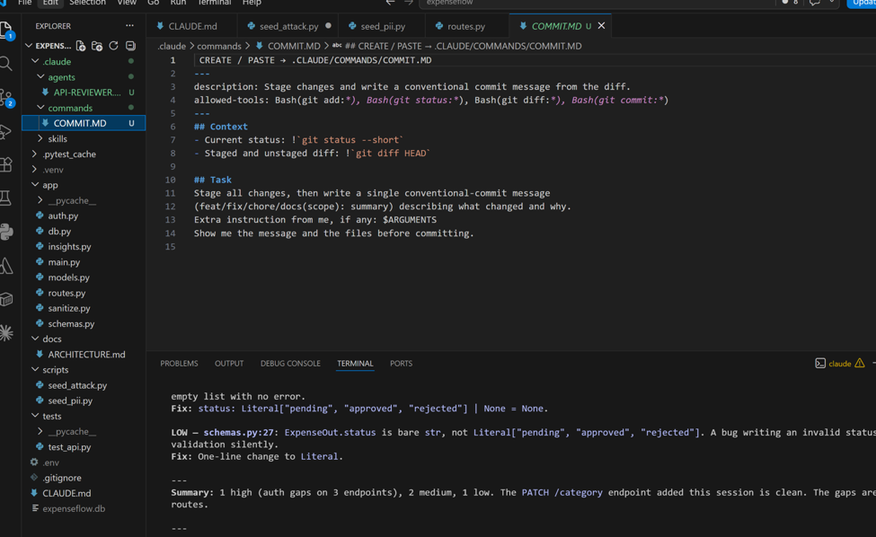

4 | Use the command
Run your new command. The diff is gathered automatically by the !`...` context lines, so you just confirm.

/commit runs git status --short and git diff HEAD first, injecting your uncommitted changes into the prompt as context, plus anything you typed after the command via $ARGUMENTS. Claude then stages everything, writes a single Conventional Commit message (feat/fix/chore/docs) from the diff, and shows you the message and file list. It commits only after you approve.

Inside the session
PS> /commit also note that this commit adds the category and spend-by-category endpoints
VALIDATE Claude shows the changed files and a conventional commit message that reflects the actual diff plus your extra note, then commits after your approval. git log shows the new commit.

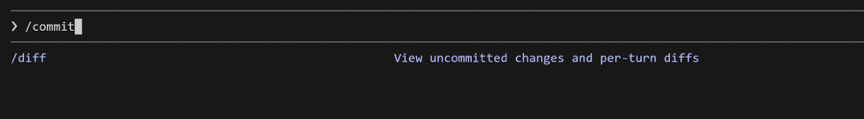
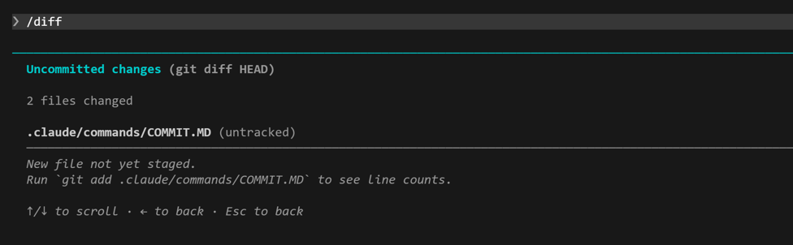

What success looks like
- A subagent in .claude/agents/ appears in /agents and can be invoked with @api-reviewer.
- You observed context isolation: the subagent's verbose work did not bloat your main session.
- A /commit command exists that pulls the live diff via !`...` and accepts $ARGUMENTS.
Common pitfalls (Windows and macOS)
- Subagents do not inherit your main session's skills or context. Give them enough in their own file to do the job.
- A skill and a subagent are different things: a skill shapes how the main Claude behaves; a subagent is a separate instance with its own window. Reach for a subagent when isolation or parallel work matters.
- allowed-tools in a command frontmatter limits what it may run. Too loose is a risk; too tight and the command stalls asking for permission.
Stretch goal
Define a second subagent, test-writer, with the single job of writing pytest tests, then ask Claude to use api-reviewer and test-writer in parallel on a change. Up to ten subagents can run at once; this is how teams parallelise.

